SIMATS ENGINEERING (SAVEETHA SCHOOL OF ENGINEERING)
Department of Computer Science and Engineering

CO1 ASSESSMENT TOOL 1 – Case Study Analysis

Course Code: | CSA10 / CSA1014 | Course Title: | Software Engineering
CO Assessed: | CO1 | Assessment: | Assessment Tool 1 – Case Study Analysis
Weightage: | 20% | Total Marks: | 25
CO1 Statement: | Apply advanced methodologies and agile project management techniques to manage software projects effectively
Student Name: | SWAMI SUJIT | Reg. No.: | 192525031
Date: | 05-10-2026 | Duration: | 60 minutes

Code of Conduct
I ____SWAMI SUJIT______________________ (Name / Reg No) certify that this submission is my original work and that I have adhered to the guidelines specified for this assessment. I understand that any violation of academic integrity rules will result in disciplinary action. Signature of the Student: ____S.SUJIT_____________________

Annexure A – Case Study Analysis

Instructions to Students:
Each student will be allotted one problem statement. Analyze the assigned problem systematically by following the steps given below. Your report should demonstrate your understanding of software engineering concepts and your ability to design an appropriate software solution.
Based on your allotted problem statement, prepare a report by answering the following questions:
- Understand the Problem Statement o Explain the problem in your own words. o Identify the objectives of the proposed system.
  - State the scope of the problem.
- Identify Key Stakeholders and Challenges o Identify all the stakeholders involved in the system. o Explain the roles and responsibilities of each stakeholder.
  - Discuss the major challenges and issues faced by the stakeholders.
- Analyze the Current Approach o Describe the existing system or current process. o Identify its strengths and limitations.
  - Analyze the problems or gaps that need to be addressed.
- Propose a Suitable Solution Using Software Engineering Principles o Design a software-based solution for the given problem.
  - Describe the major functional modules of the proposed system. o Identify the functional and non-functional requirements.
  - Explain how software engineering principles such as modularity, scalability, maintainability, reliability, usability, and security are incorporated into your solution.
- Justify the Chosen Methodology/Framework
  - Select an appropriate Software Development Life Cycle (SDLC) model or software development framework (e.g., Agile, Scrum, Waterfall, Spiral, DevOps). o Justify why the selected methodology/framework is suitable for the proposed system.
  - Explain how it supports successful project development and maintenance.
- Discuss Expected Outcomes and Limitations o Describe the expected benefits of the proposed solution. o Explain how the solution addresses the identified challenges. o Discuss potential risks, implementation challenges, and limitations. o Suggest possible future enhancements.

33. Intelligent Software License Compliance Monitoring Platform
Industry Context
Organizations use hundreds of commercial and open-source software packages. Untracked installations can create licensing, security, and compliance risks.
Problem Statement
Design and develop a software-license management platform that tracks installations, licenses, renewal dates, usage, approved versions, and compliance status.
Objectives
• Maintain software inventory.
• Track license ownership.
• Monitor license expiry.
• Identify unauthorized installations.
• Track software usage.
• Generate compliance reports.
Expected Outcomes
• Improved license visibility.
• Reduced compliance issues.
• Better software budgeting.
• Reduced unauthorized usage.
• Automated license monitoring.

1. Industry Context
Modern organizations depend on hundreds of commercial and open-source software packages. These range from operating systems and productivity suites to development tools, databases, security products and cloud-hosted services. Every package is governed by a license that defines who may use it, how many users or devices may run it, which versions are permitted and for how long.
When installations are not tracked, three connected risks appear. The first is licensing risk: running more copies than were purchased, or continuing to use software after its license has expired, exposes the organization to audit penalties and back-licensing fees. The second is security risk: unapproved or outdated software is often unpatched and widens the attack surface. The third is compliance risk: open-source licenses such as GPL, AGPL, Apache and MIT carry obligations that, if ignored, create legal exposure and can fail regulatory or customer audits.
A centralized and automated license-management platform replaces scattered spreadsheets and manual effort with continuous, auditable monitoring.

2. Problem Statement
Design and develop a software-license management platform that tracks installations, licenses, renewal dates, usage, approved versions, and compliance status.
Today, license records are usually kept in spreadsheets, emails and purchase documents, so no one has a reliable view of what is actually installed. Renewals are missed because expiry dates are not monitored, paid licenses sit unused while other products are over-deployed, and unapproved versions or shadow IT go unnoticed. Preparing for a vendor audit then takes weeks of manual and error-prone work.
The platform must therefore give IT, procurement, security and finance teams a single source of truth that answers four questions at any time: what software exists, who owns its license, whether the license is valid, and whether every installation is authorized.

3. Objectives
The platform is built around six objectives. Each one is implemented by a dedicated module described in Section 6.
No. | Objective | What the platform does
1 | Maintain software inventory | Builds and keeps a complete, current catalogue of installed software and versions.
2 | Track license ownership | Records the owner, department, vendor, type, seats and cost of each license.
3 | Monitor license expiry | Tracks renewal dates and sends staged alerts before licenses lapse.
4 | Identify unauthorized installations | Compares discovered software with approved catalogue and entitlements.
5 | Track software usage | Measures how often each application is used to find idle and over-used licenses.
6 | Generate compliance reports | Produces audit-ready reports on schedule or on demand.

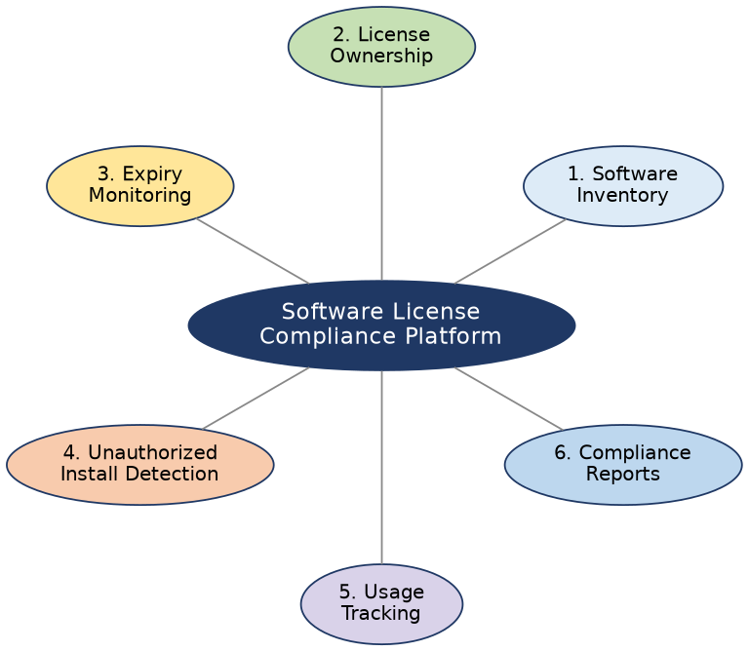
Figure 1: Platform modules mapped to the six objectives

4. Expected Outcomes
Improved license visibility. A unified dashboard shows all software, licenses, owners, versions and compliance status in one place, so questions that once took days to answer can be answered in seconds.
Reduced compliance issues. Installations are compared continuously with entitlements and policy, and early warnings are raised before a shortfall or expiry becomes a violation.
Better software budgeting. Cost and utilization analytics, renewal forecasts and the reclaiming of unused licenses support more accurate purchase and renewal decisions.
Reduced unauthorized usage. Detection of unapproved software and versions, together with alerting and tracked remediation, discourages shadow IT.
Automated license monitoring. Discovery, expiry checks, compliance scoring, alerts and reporting run on a schedule without manual effort.

5. System Architecture

5.1 Layered Overview
The platform has five layers. The data collection layer gathers installation and usage data through lightweight agents on Windows, Linux and macOS devices, agentless scans (WMI, SSH, SNMP) and integrations with directory, MDM, cloud and procurement systems. The ingestion layer receives this data through a secure API gateway and message queue, and a normalization engine maps raw package names to a standard software catalogue. The core services layer holds the business logic for inventory, licenses, renewals, compliance, usage, alerts and reporting. The data layer stores relational records, time-series usage metrics and uploaded documents. Finally, the presentation layer exposes a web dashboard, REST APIs and notification channels.
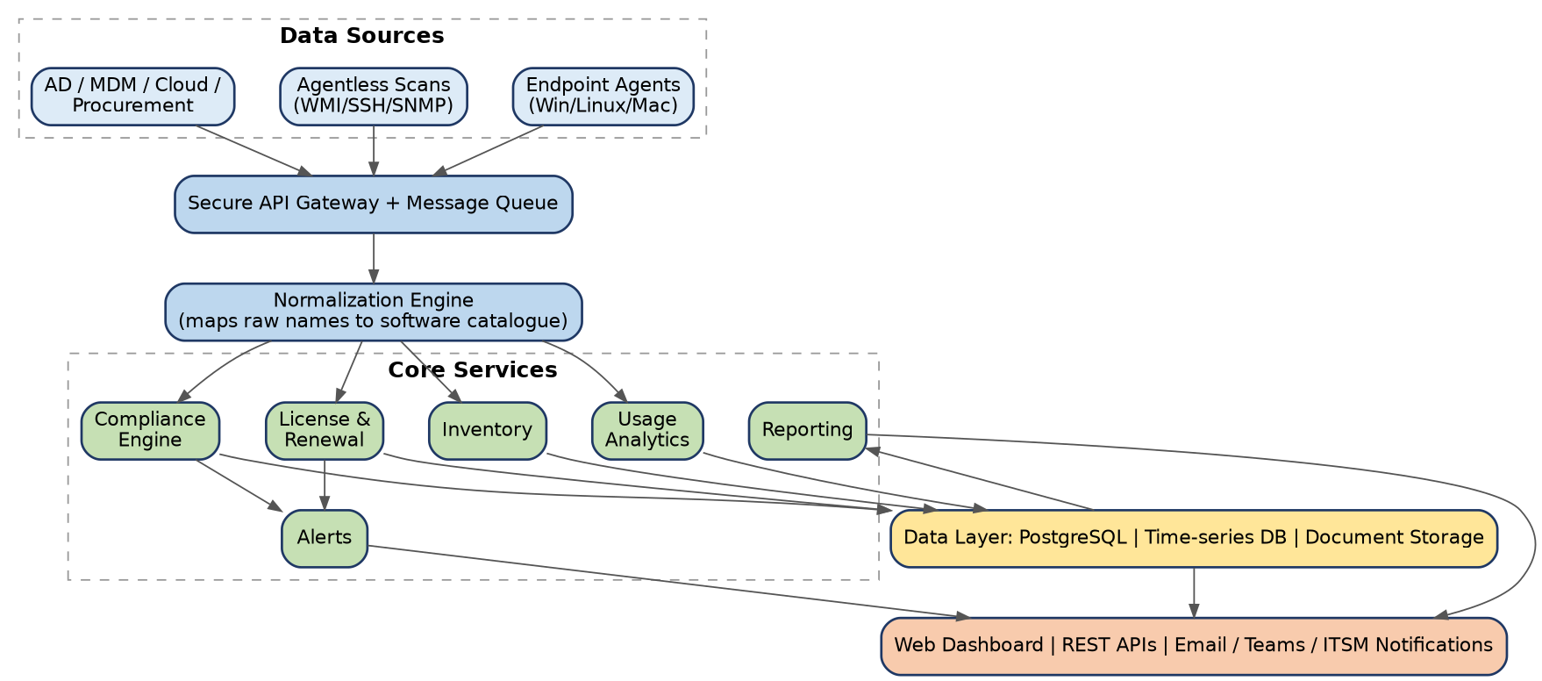
Figure 2: System architecture

5.2 Data Flow
Agents and scanners report installed software and usage to the ingestion API. The normalization engine matches each item to the catalogue, and the compliance engine then compares installations with entitlements, approved versions and policy rules. The findings update the dashboard, trigger alerts and open remediation tickets, while every result is stored so that reports can be built from the full history.

6. Functional Modules

6.1 Software Inventory Management (Objective 1)
This module discovers installed software automatically and records its version, install date and install path for each device. Discovered items are normalized into a software catalogue that stores publisher, category (commercial, open-source, freeware or SaaS), the approved versions and the end-of-life dates. Changes such as new, upgraded or removed installations are kept as history. Assets that cannot be scanned, and SaaS subscriptions, can be added manually or through CSV and Excel bulk import.

6.2 License Ownership Tracking (Objective 2)
The license register stores vendor, product, license type (perpetual, subscription, per-user, per-device, concurrent, site or open-source), license key or reference, and number of seats. Each license has a business owner, a technical owner, a department and a cost centre, and carries purchase details such as purchase order, invoice, cost and supplier. Seats can be allocated to users or devices, giving a clear entitlement-versus-consumption view. Agreements and proofs of purchase are stored with the license, and open-source packages record their obligations such as attribution or copyleft.

6.3 License Expiry and Renewal Monitoring (Objective 3)
A renewal calendar shows every upcoming expiry. Alerts go out 90, 60, 30, 15 and 7 days beforehand and escalate from the license owner to the manager and procurement. If a license is not renewed, its status changes to Expired and installations still running on it are flagged. The module also supports renewal workflows, vendor notice periods and a cost forecast for the coming quarter and year.
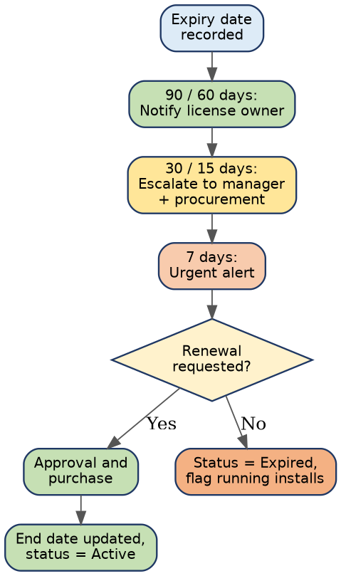
Figure 3: License expiry and renewal alert flow

6.4 Unauthorized Installation Detection (Objective 4)
After every scan, each installation is evaluated against a fixed sequence of checks, shown in Figure 4. The result is a severity level (Critical, High, Medium or Low), an assigned owner and a tracked remediation path such as uninstalling, purchasing a license, approving an exception or upgrading the version.
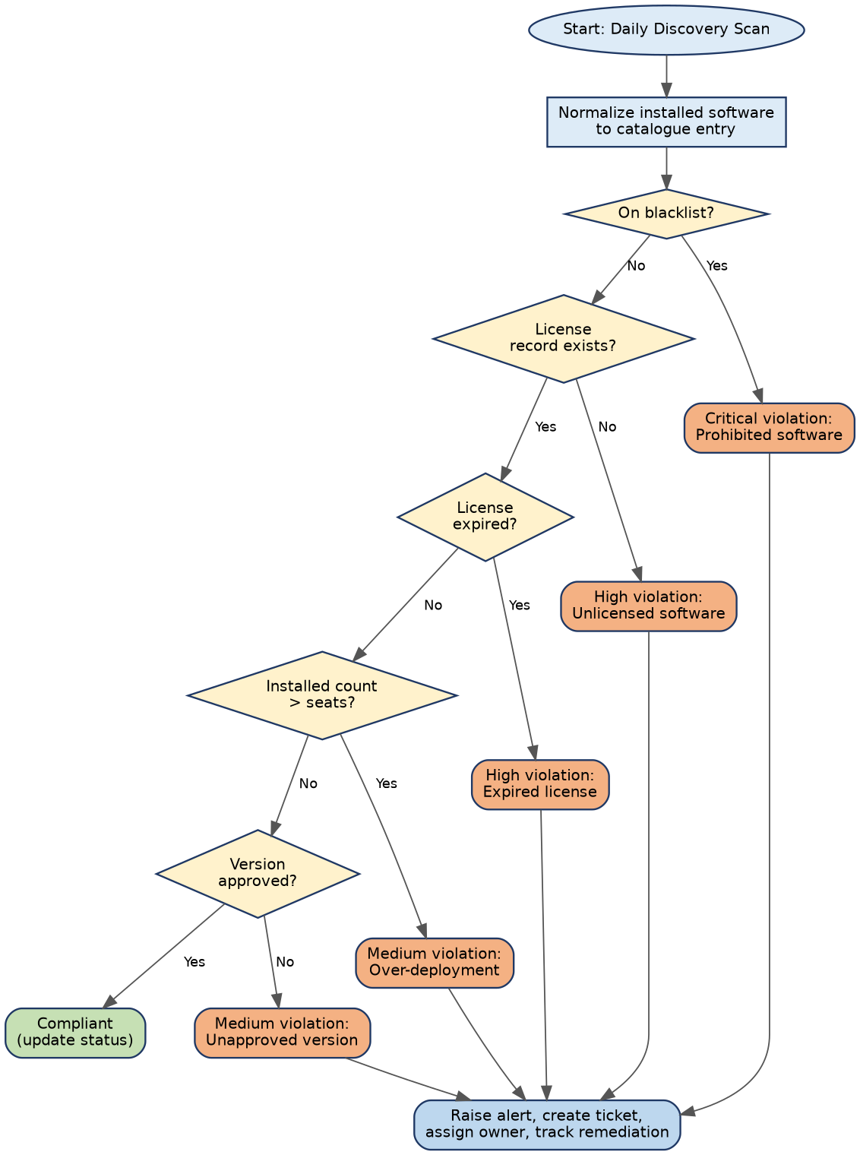
Figure 4: Unauthorized installation detection flowchart
The violation types the engine recognizes are summarized below.
Violation type | Detection rule
Unlicensed software | Installed product has no matching license record.
Over-deployment | Installed count exceeds purchased seats.
Expired license | Installation continues after the license end date.
Unapproved version | Version is outside the approved list or is end-of-life.
Blacklisted software | Product appears on the prohibited-software list.
Restricted open-source | Package uses a license the policy disallows (for example AGPL).
Shadow IT | Software installed outside the approved catalogue.

6.5 Software Usage Tracking (Objective 5)
Agents collect launch counts, active hours and last-used date for each user, device and application. Licenses that have not been used for a set period, such as 60 or 90 days, are marked as idle and suggested for reclaim and reassignment. For concurrent licenses the module analyses peak simultaneous use, and a usage-versus-cost view shows the real cost per active user. To protect privacy, only application-level metrics are collected and no content is captured.

6.6 Compliance Reporting (Objective 6)
The platform generates seven standard reports: software inventory, license entitlement versus consumption, expiry and renewal, unauthorized software, usage and optimization, an audit-ready evidence pack for vendor audits, and an executive summary with the overall compliance score. Reports can be filtered by department, vendor, location or date range, scheduled for automatic email delivery, and exported as PDF, Excel or CSV.

7. Compliance Status Logic
Every license and product is assigned one of four statuses. Compliant means the license is valid, the version is approved and the installed count is within the seats. At Risk means the license expires within 30 days or utilization exceeds 90% of seats, and the owner is alerted. Non-Compliant means the license has expired, is over-deployed or missing, or the version is unapproved, and a remediation ticket is created. Under Review applies while an exception is awaiting approval by the compliance officer.
The overall compliance score is calculated as: Compliance Score = (Compliant products / Total products tracked) x 100, optionally weighted by risk and cost.
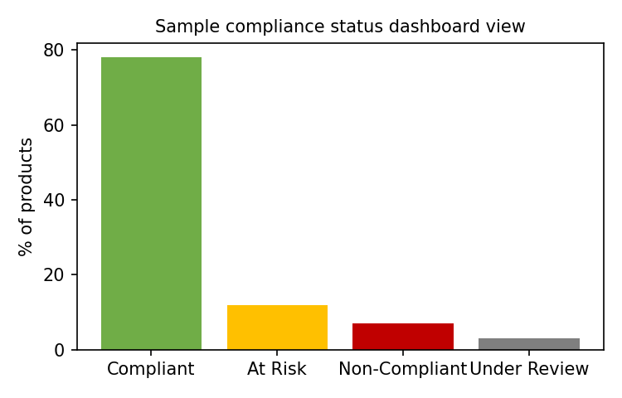
Figure 5: Sample compliance status view on the dashboard (illustrative data)

8. Data Model
The core entities are Software, SoftwareVersion, Asset, Installation, License, Owner, UsageRecord and Violation. Supporting entities (LicenseAllocation, Alert, Report and AuditLog) store seat assignments, notifications, generated reports and a trail of every change. Figure 6 shows the main relationships.
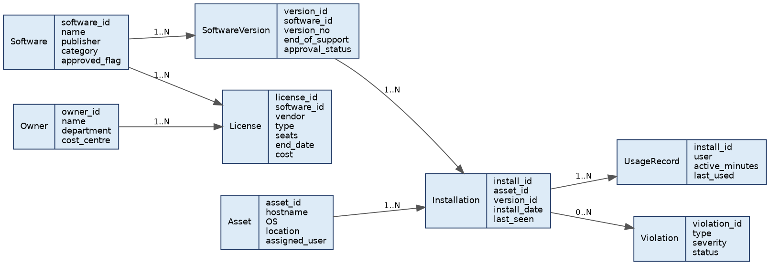
Figure 6: Entity relationship diagram (core entities)

9. Alerts and Automation
A daily discovery sync and a nightly compliance evaluation run automatically. Expiry notifications follow the staged schedule and escalate if they are not acknowledged, while blacklisted or critical software triggers an instant alert. Violations can open tickets in ITSM tools such as ServiceNow or Jira Service Management, and weekly and monthly compliance and budget reports are generated and mailed without manual work. For selected cases, an automated uninstall request or approval workflow can be enabled.

10. Technology Stack (Suggested)
Component | Suggested technology
Frontend | React or Angular dashboard with Chart.js or D3
Backend | Python (FastAPI/Django) or Java (Spring Boot) REST services
Database | PostgreSQL; TimescaleDB or InfluxDB for usage time-series
Discovery agents | Lightweight agents in Python or Go; WMI, SSH and SNMP scans
Messaging and jobs | RabbitMQ or Kafka; Celery or Quartz schedulers
Reporting | ReportLab or Apache POI for PDF and Excel output
Authentication | SSO with SAML/OAuth2; Active Directory/LDAP
Deployment | Docker and Kubernetes with CI/CD, cloud or on-premises

11. User Roles and Access Control
Access follows the principle of least privilege. Administrators configure the system, users, integrations and policies. Compliance or License Managers handle licenses, policies, violations, exceptions and reports. IT Operations staff view the inventory and remediate installations. Procurement and Finance see costs, renewals and forecasts. Department Owners review and approve licenses and usage for their own department, and Auditors have read-only access to reports and the audit trail.

12. Security and Non-Functional Requirements
- Role-based access control and a full audit trail of all changes.
- Encryption in transit (TLS) and at rest, with secure storage of license keys.
- Scalability to tens of thousands of devices and thousands of software titles.
- High availability, regular backups and defined recovery objectives.
- Authenticated agents with signed updates and minimal endpoint impact.
- Compliance with data-protection rules for user and usage data.

13. Implementation Plan
The project is planned over about 22 weeks in six phases: analysis and design (3 weeks), core platform (5), discovery and monitoring (4), compliance and usage (4), reporting and dashboards (3), and testing and rollout (3). The timeline is shown in Figure 7.
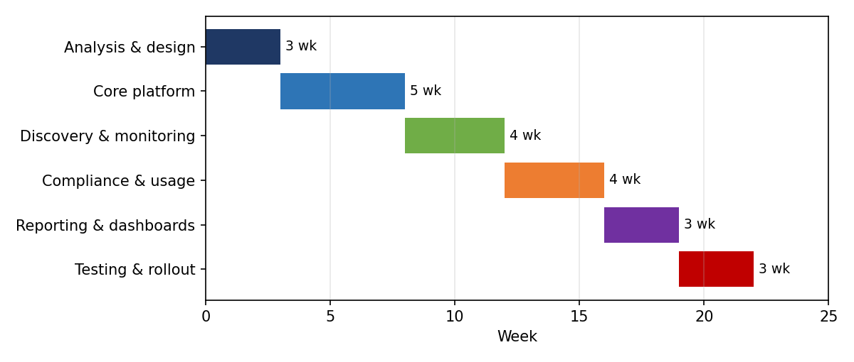
Figure 7: Implementation timeline

14. Key Performance Indicators
KPI | Target
Inventory coverage (devices discovered / total) | Above 95%
Licenses with an assigned owner | 100%
Renewals completed before expiry | Above 98%
Unauthorized installs resolved within SLA | Above 90%
Idle licenses reclaimed | 20-30% reduction
Audit preparation time | Weeks reduced to hours
Overall compliance score | Above 95%

15. Risks and Mitigation
Inconsistent software names across devices are handled by the normalization engine and a curated catalogue. Privacy concerns about usage tracking are addressed by collecting application-level metrics only and publishing a clear policy. Incomplete discovery on remote devices is reduced by agents that cache data offline and by MDM and network-scan integration. Alert fatigue is limited through severity levels, grouping and tunable thresholds, and low adoption is countered with training, simple dashboards and integration with existing ITSM tools.

16. Conclusion
The Intelligent Software License Compliance Monitoring Platform brings together inventory, ownership, expiry, unauthorized-installation detection, usage tracking and reporting in one automated system. By meeting each of the six objectives, it delivers improved license visibility, fewer compliance issues, better software budgeting, reduced unauthorized usage and automated license monitoring, and it provides the evidence needed for confident vendor and regulatory audits.

Rubrics for Calculation

Criteria | Excellent (5 Marks) | Good (3 Marks) | Satisfactory (2  Marks) | Needs  Improvement  (1 Mark)
Problem  Understanding  (30%) | Clearly explains the problem, objectives, and scope with complete understanding. | Explains the problem with minor omissions. | Basic understanding with limited explanation. | Poor understanding; objectives and scope are unclear or missing.
Stakeholder &  Challenge  Analysis (25%) | Identifies all stakeholders, their roles, and challenges with clear analysis. | Identifies most stakeholders and challenges with adequate analysis. | Identifies only a few  stakeholders or challenges. | Stakeholders and system analysis are incomplete or inaccurate.
Current System  Analysis (20%) | Thoroughly analyzes the existing system, strengths, weaknesses, and identifies all gaps. | Good analysis with most strengths and weaknesses identified. | Limited analysis with partial identification of issues. | Proposed solution is unclear or inappropriate; requirements are largely missing.
Proposed  Software  Solution &  Software  Engineering  Principles  (15%) | Proposes an innovative, feasible solution  applying appropriate software engineering principles (modularity, scalability, maintainability, security, etc.). | Suitable solution with good application of software engineering principles. | Basic solution with limited application of software engineering principles. | Methodology is inappropriate, poorly justified, or not discussed.
Methodology/  Framework  Justification  (10%) | Selects the most suitable  SDLC/model/fram ework and provides strong technical justification. | Suitable methodology selected with adequate justification. | Methodology selected but justification is weak. | Outcomes,  limitations, or future enhancements are missing; report lacks organization and clarity.

Criteria | Mark
Problem Understanding (30%) | /5
Stakeholder & Challenge Analysis (25%) | /5
Current System Analysis (20%) | /5
Proposed Software Solution & Software  Engineering Principles (15%) | /5
Methodology/ Framework Justification  (10%) | /5
TOTAL | /25

